CSC 4402: Assignment 1
John Holcomb

1.
a) Primary keys
branch: branch_name
customer: ID
loan: loan_number
borrower: ID, loan_number
account: account_number
depositor: ID, account_number

b)
∏_{employee.name (}σ employee.city = “London” ^ works.salary < 70000 (employee $⋈$ _{employee.ID = works.ID} works))

2.

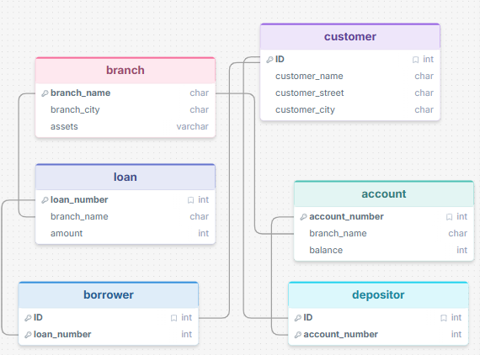

3.
a)
update instructor i
set i.salary = i.salary * 1.08
where i.salary in (select min(i.salary)
from i
where i.dept_name = ‘Comp. Sci.’);

b)
select dept_name, avg (salary)
from instructor
where avg (salary) between 52000 and 75000
group by dept_name;

4.
a)
Select ID
From works
Where salary > all (select salary
from works
where company_name = ‘Bank of America’);

b)
The two separate updates are not atomic, as they are executed sequentially. It Is possible that one query would be executed, but not the other, in a fail/crash, leading to potential double salary bumps.

Correct query:
Update works
Set salary = salary * 1.09 - salary * 0.06 * (salary * 1.09 > 100000)
Where ID in (Select manager_id from manages)
and company_name = 'JP Morgan Chase';

